**Problem Statement**

To assess the impact of remote work on employees' mental health, this analysis seeks to identify and quantify the factors contributing to mental health outcomes among remote workers. By examining variables such as age, workload, work-life balance, job satisfaction, and total working hours, we aim to determine the correlations between remote work and mental health indicators, categorize employee age groups, and identify trends across demographics. The goal is to provide actionable insights to inform company policies for supporting mental well-being in remote work environments.

**Data requirement**

To effectively assess the impact of remote work on employees' mental health, the required data should be sourced from an organization offering hybrid work options, allowing for comparative analysis between remote, on-site, and hybrid work arrangements. Key variables for this analysis should include:

**Demographic Information:** Age, gender, and other relevant demographic factors to understand trends across different groups.

**Work-Related Metrics:**

Workload: Quantitative measures of workload to assess how it varies across work settings.

Total Working Hours: Data on actual hours worked per week, including any patterns of overtime.

Work-Life Balance: Self-reported balance between personal and professional responsibilities.

Job Satisfaction: Levels of satisfaction related to role, career growth, and work environment.

**Mental Health and Well-being:**

Mental Health Status: Self-reported mental health conditions or stress levels, assessed through standardized surveys or mental health screening tools.

Access to Mental Health Resources: Availability and usage of resources such as counselling, mental health days, and Employee Assistance Programs (EAPs).

Productivity Levels: Changes in productivity or performance ratings to identify any correlation with work arrangement and mental health.

Sleep Patterns: Data on sleep quality and regularity, as sleep is a critical factor impacting mental health.

This data will enable a comprehensive analysis of how different work settings impact employees' mental well-being, productivity, and overall job satisfaction, guiding strategies for enhancing mental health support across diverse working arrangements.

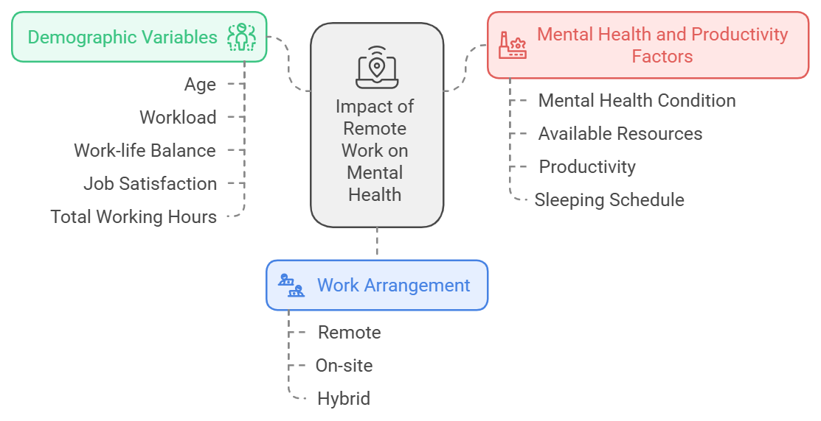

**Data Collection**

**1. Employee Surveys and Questionnaires**

Internal Employee Well-being Surveys

Industry or Sector-Specific Surveys

Public Health Surveys

**2. Human Resources Data**

Employee Demographics.

Absenteeism and Attrition Rates

Engagement Metrics:

**3. Health and Wellness Program Data**

Usage Statistics for Employee Assistance Programs (EAPs)

Health and Wellness Reimbursement Claims

**4. Productivity and Time Management Tools**

Time Tracking Software: Data from tools like Toggl, Clockify, or internal time tracking to gauge overtime hours or irregular working hours.

Project Management Tools

**5. External Mental Health Studies and Reports**

Research Studies from Mental Health Organizations: Reports from organizations such as the American Psychological Association (APA), Mental Health America (MHA), and National Institute of Mental Health (NIMH).

Academic and Research Institutions

**6. Public and Open Datasets**

National Employment Surveys

Remote Work Platforms

COVID-19 Remote Work Studies

**7. Social Media and Online Forums**

Employee Reviews and Comments

Discussion Forums

**8. Insurance and Health Records**

Health Claims Data

Occupational Health Reports

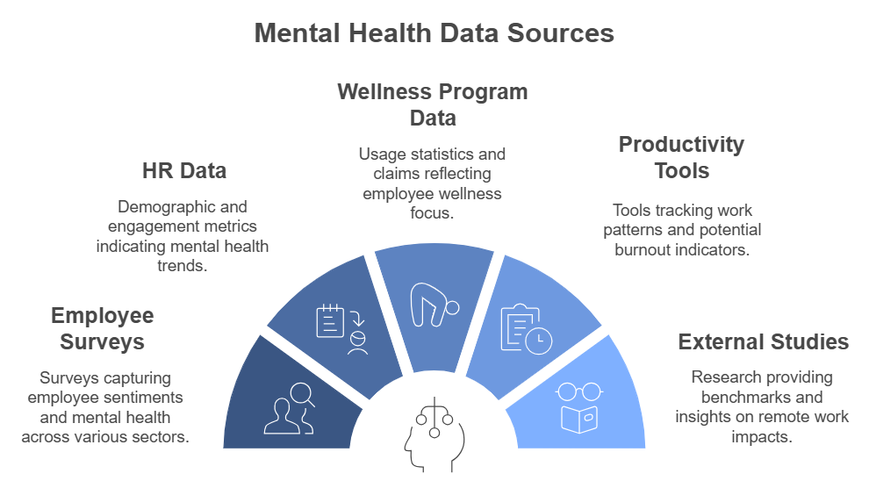

**Data Validation**

Data validation ensures the accuracy, consistency, and reliability of data before analysis, especially when evaluating sensitive topics like mental health. Here are some recommended steps for validating the data for this study on the impact of remote work on mental health:

**1. Data Source Validation**

Credibility Check: Ensure that the data sources, such as surveys or HR records, are credible and that survey instruments (e.g., questionnaires) are validated by experts in mental health or occupational health.

Consistency Across Sources: If data is collected from multiple sources (e.g., HR systems, employee surveys), verify consistency between sources for metrics like working hours and workload.

**2. Data Completeness Validation**

Missing Data Identification: Check for missing values in critical fields (e.g., age, work setting, job satisfaction, mental health status).

Imputation or Handling Missing Values: For non-critical fields with missing data, decide on a method to handle missing values (e.g., mean/mode imputation, or flagging for further investigation).

**3. Data Type Validation**

Data Type Consistency: Ensure that all variables have the correct data types. For instance, age should be numeric, work setting categorical (e.g., "Remote," "On-site," "Hybrid"), and workload scores either integer or float.

Range Checks: Check that values fall within expected ranges (e.g., age between 18 and 65, working hours within a reasonable weekly range).

**4. Validation of Categorical Values**

Predefined Lists: Ensure that categorical variables such as work setting, mental health condition (e.g., "Good," "Average," "Poor"), and access to resources use only predefined, consistent categories.

Uniform Spelling/Format: Validate that text fields (e.g., work setting names) are consistently spelled/formatted.

**5. Logical Consistency Checks**

Correlate Related Variables: Check for logical consistency between related fields. For instance:

Workload and Productivity: Higher workloads should logically align with changes in productivity or satisfaction scores.

Work Hours and Work Setting: Remote or hybrid employees might show different working hour patterns compared to on-site employees.

Cross-Reference Demographics: Ensure demographics such as age and years of experience align with job levels or expected career stages.

**6. Outlier Detection**

Identify Outliers: Use statistical methods (e.g., z-scores, IQR) to detect and flag unusually high or low values in quantitative fields like working hours or sleep schedule.

Manual Review: Investigate outliers to determine if they represent genuine cases or data entry errors.

**7. Data Accuracy Checks**

Back-Check with Source: If feasible, verify data entries against original records or conduct spot-checks to confirm accuracy.

Survey Integrity Checks: For survey responses, apply attention checks or flag inconsistent responses to ensure participants engaged with the survey sincerely.

**8. Temporal Consistency**

Consistent Time Periods: Verify that all data is from the same relevant time period (e.g., the last 6 months) to ensure comparability.

Seasonal Variability Consideration: For mental health data, ensure consistency across different times of the year, as mental health can fluctuate with seasonal factors.

**9. Validation of Derived Metrics**

Recalculate Derived Fields: For fields calculated from raw data (e.g., average weekly hours, workload index), validate calculations to ensure correct formulas were applied.

Cross-Check Aggregates: Compare summary statistics (e.g., average job satisfaction scores) against expectations or benchmarks to identify any anomalies.

**10. Pilot Testing (if feasible)**

Small-Scale Test: If new survey questions or metrics are added, conduct a pilot test with a small group to identify and correct any issues in question clarity, data collection, or response patterns.

**Data Preprocessing**

**1. Data Cleaning**

Handle Missing Values: Identify missing values and decide on a handling method:

Remove rows with missing data for non-critical fields.

Impute values for important fields, using methods such as mean, median, or mode, or advanced methods like K-Nearest Neighbors (KNN) imputation if applicable.

Flag missing data in key fields to avoid imputation bias, especially for sensitive variables like mental health scores.

Correct Errors and Inconsistencies: Detect and fix any data entry errors or inconsistencies (e.g., ensure correct spelling and consistent capitalization in categorical fields like "Work Setting").

**2. Outlier Detection and Treatment**

Identify Outliers in numerical fields (e.g., work hours, workload score, age) using z-scores or the interquartile range (IQR) method.

Treat Outliers based on their relevance:

Cap or remove outliers if they represent data entry errors or extreme values that don’t fit logically.

Retain significant outliers that might be valid but rare, such as employees with high workloads, as these could provide insights.

**3. Encoding Categorical Variables**

Label Encoding for binary categorical variables (e.g., "Yes/No" for resource availability).

One-Hot Encoding for multi-category fields like "Work Setting" (remote, on-site, hybrid) or "Mental Health Status" (Good, Average, Poor), to avoid ordinal relationships where they don’t exist.

**4. Feature Scaling**

Standardization or Normalization: Apply scaling techniques to continuous variables, such as workload score, working hours, and sleep duration.

Standardization (z-score scaling) for features with a Gaussian distribution.

Normalization (min-max scaling) for features that need to be constrained between 0 and 1, such as scores on a 0-100 scale.

**5. Date and Time Preprocessing**

Convert Date Fields: If the data includes timestamps (e.g., survey date, login times), convert these to datetime format.

Extract Temporal Features: Derive features like day of the week, month, or season to observe potential trends in productivity, mental health, or sleep patterns.

**6. Text Data Preprocessing**

Handle Open-Ended Survey Responses: For textual survey responses (e.g., descriptions of mental health challenges), apply text cleaning steps:

Remove Stop Words: Exclude commonly used words that don’t add meaning.

Tokenize and Lemmatize: Break down text into tokens and reduce them to their root forms to normalize the text data.

Sentiment Analysis: Optionally, use sentiment analysis to categorize responses by sentiment polarity (positive, neutral, negative) to gauge mental health sentiment.

**7. Creating Derived Features**

Binary Work Environment Flag: Create a binary variable (e.g., IsRemote) to simplify comparisons between remote vs. on-site work settings.

Workload Index: Calculate a composite workload score if multiple metrics (e.g., work hours, task count) contribute to the workload.

Mental Health Risk Score: Aggregate related mental health measures to create a risk index that may reveal deeper insights into overall mental health.

**8. Handling Imbalanced Data**

Class Balancing: If mental health categories are imbalanced (e.g., more reports of "Good" than "Poor" mental health), apply techniques like:

Resampling (oversampling/undersampling) to balance classes.

Synthetic Data Generation (SMOTE) to create synthetic instances of underrepresented classes.

**9. Data Transformation**

Log Transformation: Apply logarithmic transformation to highly skewed numerical features, like work hours, if they show a non-normal distribution.

Polynomial or Interaction Features: Create interaction terms (e.g., Work Hours * Job Satisfaction) to capture complex relationships that may influence mental health.

**10. Data Splitting for Training and Testing**

Train-Test Split: Divide the data into training and testing sets if you plan to use machine learning models. Ensure that the split is random and stratified if analyzing categorical outcomes like mental health status.

Cross-Validation: Use k-fold cross-validation for a more robust model evaluation process.

**11. Data Quality Checks Post-Preprocessing**

Summary Statistics Review: Recheck summary statistics (mean, median, min, max) to ensure that scaling and encoding steps did not introduce unintended biases.

Correlation Matrix Analysis: Inspect the correlation matrix to confirm relationships among features and check for multicollinearity.

Visual Inspection: Plot distributions of preprocessed data to identify any remaining anomalies visually.

**Tools**

**1. Advanced Excel**

* Excel is a powerful tool for data analysis and is widely used for tasks such as data organization, manipulation, and visualization. Advanced Excel goes beyond basic functions, leveraging features like pivot tables, complex formulas, macros, and data analysis add-ins.
* It’s ideal for handling relatively small datasets and performing tasks like summarizing, filtering, and analyzing data quickly. Advanced Excel is great for generating automated reports, conducting statistical analysis, and creating interactive dashboards.

**2. SQL (Structured Query Language)**

* SQL is a programming language used to manage and query data within relational databases. It allows users to retrieve, update, manipulate, and analyze large datasets directly from databases.
* SQL is crucial for data extraction and preparation. Analysts use it to query specific subsets of data, join tables, aggregate information, and perform transformations directly in a database, which makes it highly efficient for big data tasks.

**3. Python**

* Python is a versatile, high-level programming language widely used in data analysis, machine learning, and automation. It offers extensive libraries like Pandas, NumPy, Matplotlib, and Scikit-Learn that simplify complex data processing tasks.
* Python excels in data manipulation, statistical modeling, predictive analytics, and data visualization. With its libraries, analysts can clean data, perform exploratory data analysis, build machine learning models, and create complex visualizations, making it highly valuable for both data science and business analytics.

**4. Power BI**

* Power BI is a business intelligence tool from Microsoft that allows users to create interactive dashboards and reports. It connects to multiple data sources and enables real-time data visualization and sharing.
* Power BI is ideal for creating interactive dashboards that present data in a user-friendly way. Analysts can visualize trends, create KPI metrics, and explore data insights that can be easily shared across teams or embedded within apps, making it a preferred tool for business reporting.

**5. Tableau**

Tableau is a powerful tool widely recognized for its ability to analyze and visualize data effectively. Here's how it stands out:

1. User-Friendly Interface

Drag-and-Drop Functionality: Tableau’s intuitive drag-and-drop interface allows users to create charts, graphs, and dashboards without needing advanced technical skills.

Interactive Design: Users can interact with visualizations by applying filters and drilling down into data for deeper insights.

2. Data Integration

Versatile Data Connections: Tableau connects seamlessly to multiple data sources, including Excel, SQL databases, cloud services (e.g., Salesforce, AWS), and APIs.

Live and Extract Connections: You can work with real-time data (live connections) or download a snapshot for offline use (extracts).

3. Advanced Visualization Capabilities

Wide Range of Visuals: Tableau supports diverse chart types, such as heatmaps, treemaps, scatter plots, line graphs, and more.

Customizable Dashboards: Combine multiple visualizations into interactive dashboards that provide a holistic view of your data.

Storytelling Features: Build visual narratives by arranging dashboards and charts into a sequence for presentations.

4. Analytical Power

In-Depth Analysis: Tableau enables trend analysis, forecasting, clustering, and statistical summaries.

Calculated Fields: Users can create custom calculations to derive additional insights directly within Tableau.

AI Integration: Features like Explain Data leverage AI to provide insights into patterns and anomalies.

5. Interactivity and Collaboration

Filters and Highlighting: Tableau visualizations are interactive, allowing users to slice and dice data dynamically.

Sharing and Collaboration: Publish dashboards to Tableau Server or Tableau Online, enabling teams to collaborate and access insights securely from anywhere.

Mobile Optimization: Dashboards can be optimized for mobile devices, ensuring accessibility across platforms.

6. Scalability and Performance

Scalable for Big Data: Tableau handles large datasets efficiently with tools like Hyper (its in-memory data engine).

High Performance: Tableau processes and visualizes data rapidly, even for complex analytics tasks.

7. Community and Support

Extensive Resources: Tableau offers rich documentation, tutorials, and an active user community for learning and troubleshooting.

Regular Updates: Tableau continually evolves, introducing new features to enhance user experience and functionality.

**Dashboard**

A dashboard is a visual display of data that consolidates and organizes information from multiple sources into a single, interactive interface. It provides a comprehensive view of key metrics and trends, making it an essential tool for analysis and visualization.

**Data Consolidation**

Aggregates data from various sources, enabling unified analysis.

Reduces the need to switch between different datasets or platforms.

**Real-Time Insights**

Displays live or frequently updated data, allowing timely decision-making.

Highlights trends, anomalies, and patterns as they occur.

**Enhanced Understanding**

Translates raw data into visually digestible formats like charts, graphs, and maps.

Simplifies complex datasets, aiding in better comprehension.

**Interactivity**

Enables users to filter, drill down, and customize views for detailed analysis.

Provides flexibility in exploring data from multiple perspectives.

**Performance Monitoring**

Tracks and measures key performance indicators (KPIs) effectively.

Facilitates goal-setting and progress assessment.

**Improved Communication**

Serves as a powerful storytelling tool to present data to stakeholders.

Encourages data-driven discussions and decision-making.

**Efficiency**

Saves time by automating data updates and reducing manual reporting.

Centralizes data for quick access and analysis.